City of North Wildwood
Fire Prevention & Inspection Bureau
901 Atlantic Avenue
North Wildwood, New Jersey 08260
Office - 609-522-2160
Fax – 609-846-9995

Application for a Certificate of Smoke Alarm, Carbon Monoxide
Alarm and Portable Fire Extinguisher Compliance (CSACMAPFEC)

Property Address: _________________________________________________________ Block# __________ Lot# _________

# of units for sale: _________ Settlement Date: ____/____/____ Key Attached: _______ Access Code: __________

Seller/Agent: ___________________________________ Phone# ______________________ Fax# _____________________

Seller/Agent Email: ________________________________________________________________________________________

I, ______________________________________________, certify that I am the owner or authorized agent the above property and request that a CSACMAPFEC inspection be performed. I further certify that all fire related equipment shall be installed in accordance with the N.J. State Fire Code and inspected per the requirements listed on opposite side of this application.

Send Certificate to:

Name: __________________________________________ Email Address: __________________________________________

Address: __________________________________________________________________________________________________

City/State/Zip: ____________________________________________________________________________________________

New Buyer Information:

Name: __________________________________________ Email Address: __________________________________________

Address: __________________________________________________________________________________________________

City/State/Zip: ____________________________________________________________________________________________

Fee Schedule:

- $25.00 Fire Code Status Report for registered properties (search for pending violations/fees)
- $45.00 per unit if application is received more than 10 business days prior to settlement
- $90.00 per unit if application is receives between 4 and 10 business days prior to settlement
- $161.00 per unit if application is received less than 4 business days prior to settlement
- Re-inspection fees are equal to the cost of the initial application inspection fee

Office Use Only:

Fee Enclosed: $___________________________ Check#: __________________________ Cash: $_____________________

Pending Fees: $_________________________________________ (see attached invoice) Date: ______/_______/_______

****** REQUIREMENTS PRIOR TO INSPECTION ON BACK ******
Please read prior to completing this application

Dear applicant,

Please read these instructions prior to filling out your application for the CSAMACPFEC. Fill out the application accurately and in its entirety. If the required fields are not completed the application will not be processed. Prior to submitting the application, please ensure the property has the following:

- Smoke Alarms -
  - are required in each sleeping room/area
  - are required outside (within 10’) of each sleeping room/area
  - are required on every level of the building (including attics)
  - refer to the manufacturer’s instructions for additional guidance for the placement of smoke detectors

Note: All smoke alarms must be installed and in working order at the time of inspection.

  - Hardwired smoke alarms – must be replaced if older than 10 years after the date of manufacture (can be located on back of alarms)
  - Battery smoke alarms – must be the 10 year sealed battery type smoke alarms

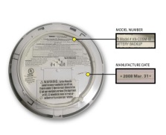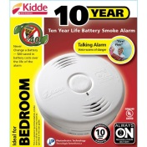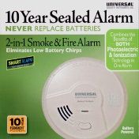

- Carbon Monoxide Alarms – are required (as listed below) in any building where there are fuel burning appliances (i.e. natural or LP Gas heat, cooking, oil heat, fire places, etc.) It is also required if there is an attached garage to the building.
  - are required outside (within 10’) of each sleeping room/area
  - are required on every level of the building

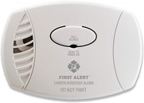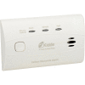

- Fire Extinguishers – Must be a minimum size of 2A:10BC, be a new (current year) extinguisher or certified (properly tagged by a licensed fire protection agent) for each cooking area(s). It must be hung in a visible location or within a properly labeled cabinet.
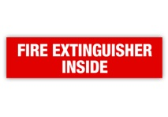
Please DO NOT submit this application until all the above requirements have been met. Once it is received the fire inspector will conduct the inspection as soon as possible. If providing keys or a lock box code for the property please note on the application. If the property does not pass the initial inspection a re-inspection must be scheduled and a re-inspection fee will be charged. Please feel free to contact the office if you have any questions at 609-522-2160.

Thank you for your cooperation

